**Date:10.09.25**

**TASK:7**

**Implementation of Monkey Banana Problem in Goal Stack planning using python by applying following constraints.**

Implementation of Monkey Banana Problem in Goal Stack planning using python by applying following constraints.

Imagine a room containing a monkey, chair and some bananas. That have been hanged from the centre of ceiling. If the monkey is clever enough, he can reach the bananas by placing the chair directly below the bananas and climb on the chair. The problem is to prove the monkey can reach the bananas. The monkey wants it, but cannot jump high enough from the floor. At the window of the room there is a box that the monkey can use. The monkey can perform the Following actions: -

1) Walk on the floor.

2) Climb the box.

3) Push the box around (if it is beside the box).

4) Grasp the banana if it is standing on the box directly under the banana.

**Tools: Python**

**PROBLEM STATEMENT: CO3 S3**

A mischievous monkey is standing on the ground at position 0 in a room. A bunch of bananas is hanging from the ceiling at position 1, just out of the monkey’s reach. There is a box placed at position 2. The monkey’s goal is to get the bananas. The monkey can perform actions such as moving between positions, pushing boxes, and climbing on boxes to reach higher places. Your task is to determine the correct sequence of actions the monkey should take to successfully grab the bananas while using the available box.

**IMPLEMENTATION OF MONKEY BANANA PROBLEM**

**IN GOAL STACK PLANNING**

**AIM**

To Implement the Monkey Banana Problem in Goal Stack planning using python

**ALGORITHM**

1. Start: Place the monkey at its initial position on the ground.
2. Identify goal: Monkey’s goal is to get the bananas.
3. Check reach: If the monkey can reach the bananas directly, go grab them (not possible here).
4. Locate box: Find the position of the box in the room.
5. Move to box: Monkey walks to the box’s position.
6. Check position: If the box is not under the bananas, plan to push it.
7. Push box: Monkey pushes the box to the position directly under the bananas.
8. Climb box: Monkey climbs on top of the box.
9. Grab bananas: Monkey reaches out and grabs the bananas.
10. End: Goal achieved — monkey has the bananas.

**PROGRAM**

**Monkey and Bananas Program**

# Initial positions

monkey_pos = 0

box_pos = 2

banana_pos = 1

# Actions list to store the plan

plan = []

# Step 1: Move to the box

plan.append(f"Monkey moves from {monkey_pos} to {box_pos}")

monkey_pos = box_pos

# Step 2: Push the box under the bananas

plan.append(f"Monkey pushes the box from {box_pos} to {banana_pos}")

box_pos = banana_pos

monkey_pos = box_pos

# Step 3: Climb the box

plan.append(f"Monkey climbs the box at position {box_pos}")

# Step 4: Grab the bananas

plan.append(f"Monkey grabs the bananas at position {banana_pos}")

# Print the plan

print("Plan for the Monkey to get the Bananas:")

for action in plan:

print("-", action)

**OUTPUT**

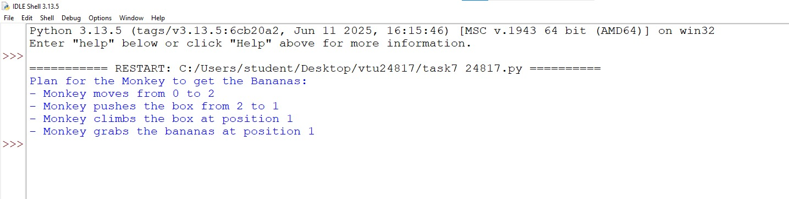

**RESULT**

Thus, the Implementation the Monkey Banana Problem in Goal Stack planning using python was successfully executed and output was verified.